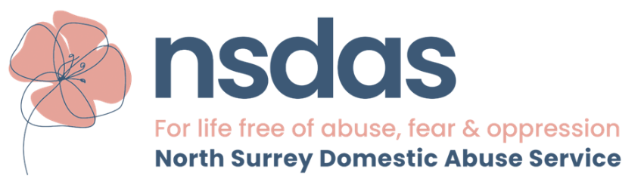

NORTH SURREY DOMESTIC ABUSE SERVICE
Please note: This post is restricted to female applicants in accordance with Schedule 9 (part 1) of the Equality Act 2010
SUMMARY
NSDAS (North Surrey Domestic Abuse Services) is an independent charity providing outreach and associated services in the North Surrey area. NSDAS is a close team of diverse women, united by ultimate goal of eradicating domestic abuse in all its forms and advocating on behalf of survivors and their children.

You will work closely with the Chief Executive Officer.
JOB DESCRIPTION
POST TITLE | Operations Manager
DAYS / HOURS | 3 days a week / 21 hours a week
SALARY | £20,000 - £24,000 pa
DURATION | 12 Month Contract
REPORTS TO | CEO
LOCATION | Walton-on-Thames office
HOLIDAY AND PENSION | FTE: 20 days holiday per annum plus paid Bank Holidays, increasing with each full year of service up to 30 days and option of enrolment in pension scheme

1. ACCOUNTABILITY
The post holder is accountable and will be supervised by the Chief Executive and work in partnership with the Service Managers

2. KEY AREA OF RESPONSIBILITY
The key purpose of the role is to provide management of Staff, HR, the Service, Health and Safety, Office Maintenance for the day to day running of the business.
Staff Management
- Create and maintain a positive working environment
- Implement and maintain effective performance management and development of staff, including appraisals and learning and development
- Monitor to ensure that the service is adequately staffed and resourced
- Lead by example in encouraging good communication and teamwork
- Assist the CEO in implementing employment policies and processes
- Oversee recruitment and induction policies and procedures
- Organise and deliver an impactful learning and development strategy across the organisation
Service Delivery
- Ensure excellent operational procedures are fully implemented and maintained across the service
- Create positive and co-operative communication between colleagues in all services to ensure referrals. Key working, risk assessments and support planning are consistently made to a high standard and acted upon effectively
- Monitor and report on performance and statistics for all partners, services and funders according to agreed formats and schedules as requested
Finance Management
- Work with Finance Manager to ensure
  - Expenses and invoices are paid
  - All reporting to Trustee Board is done
- Liaise with Surrey Domestic Abuse Partnership to ensure that income and expenditure with respect to joint contracts is done

Fund Raising Management
- Fund raising within NSDAS, to include Statutory, Corporate, Community fund raising
- Recruiting necessary fund raising resources, responsible for running of Fund Raising Committee
Office Management
- Oversee all aspects of health and safety including fire safety, IT equipment, phone equipment
Governance
- Ensure all policies and procedures are up to date and implement new one as necessary
- Ensure knowledge and compliance at all levels
- Investigate and respond to complaints
Public Relations
- Assist with the promotion of NSDAS
- Maintain contacts with local and regional media
- Attend external meetings with and on behalf of the CEO

SKILLS AND EXPERIENCE

Qualities and Behaviours
- Ability to build effective working relationships across multiple teams both inside and outside the organisation. Be able to sustain these through sometimes complex situations.
- Service orientated. Motivated to deliver a high-quality service and have the ability to enthuse others to deliver their best.
- Responsible. Have an appropriate balance between being responsive to the needs of people and managing within the framework of the organisation’s objectives.
- Calm and pragmatic. This manager will need to deal with conflicting interests of resources or time so needs an ability to remain calm and retain a sense of key priorities when under pressure.
- Good problem solver and willingness to demonstrate flexibility
- Well-developed Organisational Skills and the ability to see the bigger picture.
- Forward-thinker interested in continual improvement.

Experience
- Operational management experience, gained in complex service organisation, with experience of line management preferably to include experience of working with volunteers
- Proven experience of innovation and creativity to improve quality of service
- Excellent IT and numeracy skills
- Knowledge of Domestic Abuse and delivery of services to support survivors would be a distinct advantage
- Experience and knowledge of current employment legislation would be an advantage

Please note: This post is restricted to female applicants in
accordance with Schedule 9 (part 1) of the Equality Act 2010

