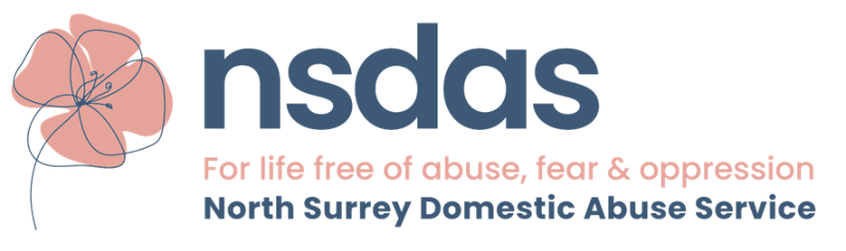

NSDAS JOB APPLICATION FORM
Working with Adults, there is a different form if applying for working with children
We recognise the positive value of diversity, promoting equality and fairness, and challenging discrimination. We welcome our legal duties not to discriminate as a service provider and an employer. We aim to go beyond the narrow scope of legislative compliance and follow best practice, making equality, fairness and diversity a fundamental part of all our activities. We recognise people with different backgrounds, skills, attitudes and experiences bring fresh ideas and perceptions, and we wish to encourage and harness these differences to make our services more relevant and approachable.
Position applied for: | Name: | Date:

Personal details
Full name (surname and first name):

Title (e.g., Mr/Mrs/Ms/Dr):

Preferred Name
Address

Postcode

Mobile telephone Number

Email

Working Arrangements
Are you eligible to work in the UK? (Yes/No)

Do you require a work visa? (Yes/No)
Do you hold a full UK driving licence? (Yes/No)
Are there any alterations to the working environment that would make your daily tasks easier?

Present / Last Employment
Employer name:

Address:

Postcode:
Your Job title:

Dates of employment:
Current salary (optional):
Reason for leaving (if applicable):

Past Employment (last five years)
Employer name:

Address:

Postcode:
Job title:

Dates of employment:
Current salary (optional):
Reason for leaving (if applicable):

Employer name:

Address:

Postcode:
Job title:

Dates of employment:
Reason for leaving (if applicable):

Employer name:

Address:

Postcode:
Job title:

Dates of employment:
Reason for leaving (if applicable):

Employer name:

Address:

Postcode:
Job title:

Dates of employment:
Reason for leaving (if applicable):

Education and Qualifications
Institution Name:
Address (optional):
Qualification(s) achieved:

Dates attended:

Institution Name:
Address (optional):
Qualification(s) achieved:

Dates attended:

References
Full name:
Organisation name:
Job title/relationship to you:
Email Address:
Contact Number:

Full name:
Organisation name:
Job title/relationship to you:
Email Address:
Contact Number:

Why would you like to work at this charity?

Briefly outline your skills and experience that you feel would add value to the team:

Please could you tell us about a career highlight that you are most proud of?

