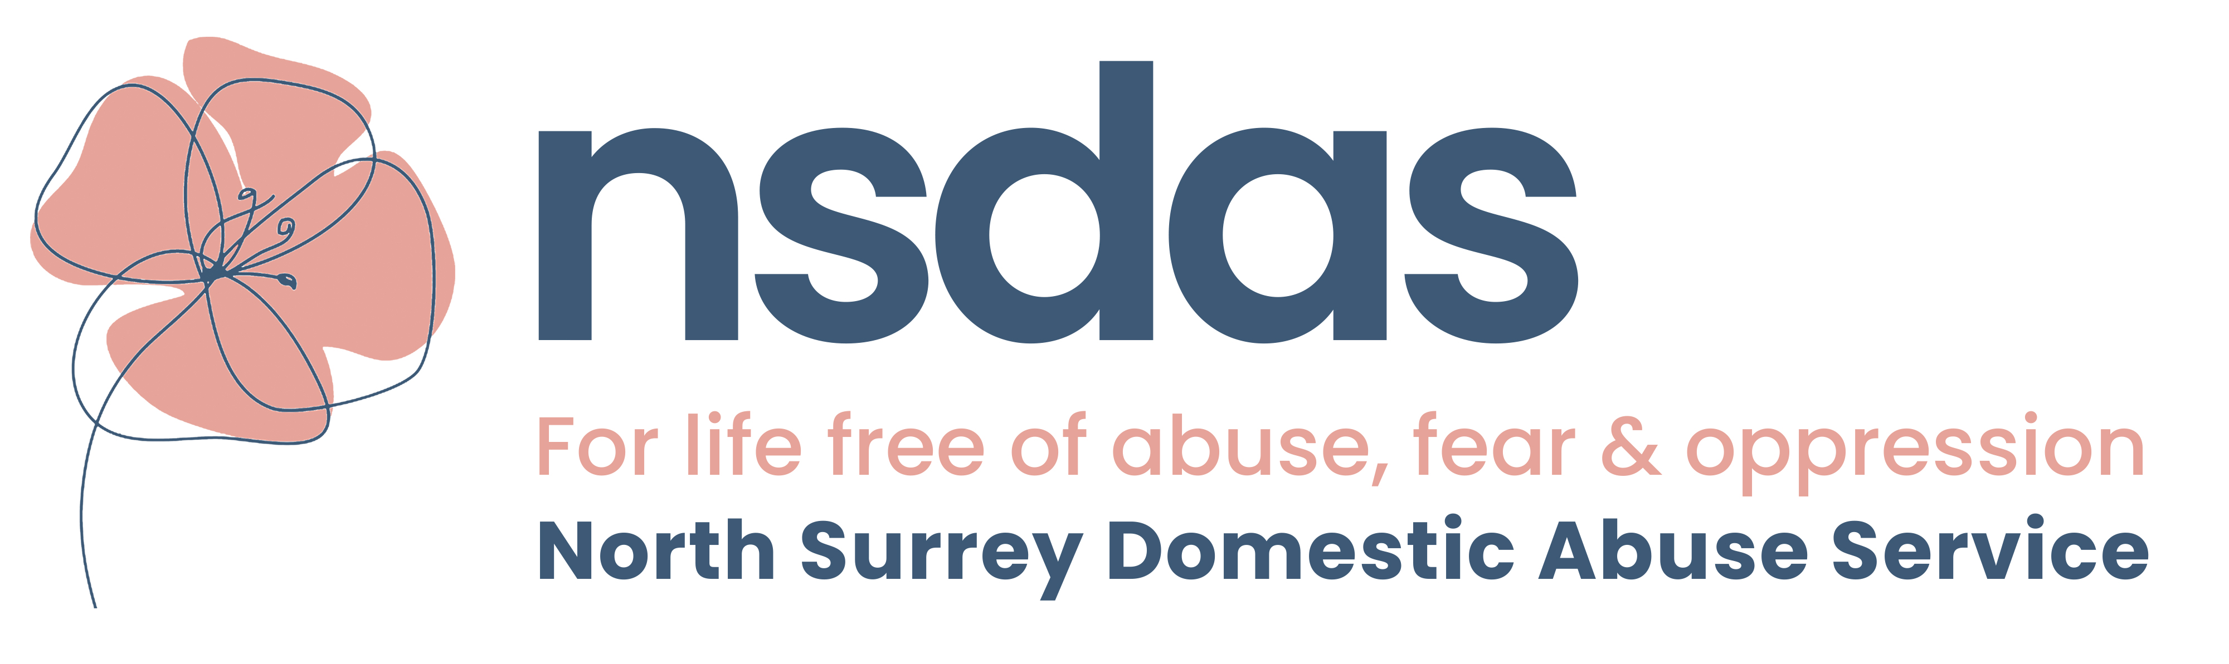

Children and Young People’s worker

Job Description

Hours: 36 hours per week/ jobshare considered

Salary: £26,000 FTE (plus contributory pension scheme)

Reporting Service Manager

Role purpose
To work with children (up to 18 years) who have experienced and/or witnessed domestic abuse and to provide & coordinate services that will enable them to make sense of their experiences, come to terms with their situation and develop and grow in self-esteem and confidence.

Key areas of responsibility

- To assess children and young people’s needs
- To build relationships that befriend and support them both practically and emotionally and help develop their resilience to face and manage life’s challenges.
- To work with them therapeutically both individually and in groups, either directly or through other appropriately qualified professionals
- To accept referrals from the Adult Outreach Service
- To provide bespoke intervention for children impacted by DA and unhealthy relationships.
- To meet with a CYP non-abusive parent to identify the needs of the CYP from their perspective.
- To build networks and close working relationships with other agencies, both statutory and voluntary who are also working with children and young people in the area and to refer, when appropriate and work with these agencies.
- To introduce Protective Behaviours strategies to children and young people
- To liaise with local CYP settings and work with them to deliver lessons on domestic abuse awareness and healthy relationships.
- To positively promote the service in all activities
- To sensitively challenge unacceptable behaviour and prejudice
- To work in collaboration with all other employees and volunteers of the service

- To provide family work sessions to non-abusive parents and their children to help rebuild connections and facilitate healthy communication techniques.
- To plan, set up, develop and/or assist with running therapeutic groups for non-abusive parents to strengthen the parent-child relationship.

Learning and development

- Identify and implement own learning and development needs in liaison with the Youth Services Manager
- To keep up to date with national curriculum changes, updating material in line with these and changes in the DA agenda
- To attend training as required

General

Applicants will need to be committed to the aims & objectives of the role and be able to develop an understanding of domestic abuse and the needs of children & young people affected by domestic abuse.

A strong commitment to equal opportunities and the potential to understand particular needs and expectations of children from different backgrounds will be required.

Essential
Those areas marked with (s) will be areas used to shortlist candidates.
Knowledge and Experience
- Experience coordinating the delivery of a service working directly with children, young people (aged up to 18 years) and their families (paid or voluntary) (s)
- Experience of working directly with children, young people (aged up to 18 years) and their families (paid or voluntary)
- Experience of working with children and young people through a range of difficult situations and supporting them accordingly
- Experience of working therapeutically with children and young people
- Knowledge of Safeguarding Children, Child Protection legislation and legal responsibilities
- Knowledge of the Children Act 1989 and 2004, issues surrounding child contact, residence and other relevant legislation.
- Understanding of, and commitment to, equal opportunities in practice

Skills and Abilities
- The ability to empower & support colleagues.
- Able to work under own initiative (s)
- Take responsibility for prioritising and organising own workload. (s)
- Able to work under pressure.
- Able to maintain professional boundaries. (s)
- Good communication skills written and verbal and effective negotiation skills.
- Hold a current driving licence and have access to a car.
- Computer literate: word processing, email etc.
- Able and willing to work in partnership with statutory and voluntary partners.
- Able to set up and run support and therapeutic groups for children and young people.(s)

Personal Qualities
- Pro active
- Compassionate and non-judgmental
- Willingness and commitment to undertake regular training and qualifications deemed relevant to the role.
- Ability to work as part of a team and motivate others.

Desirable
- Awareness of domestic abuse and its effect on children & young people
- Experience of planning a programme of activities for children and young people

