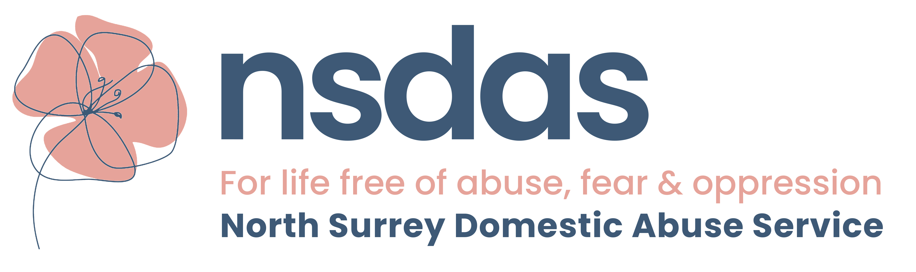

NORTH SURREY DOMESTIC ABUSE SERVICE REFERRAL FORM

CONFIDENTIAL

CLIENT DETAILS:
Name
Date of Birth
Address

Safe contact number | Safe to text/leave message Yes/No

ALLEGED PERPETRATOR DETAILS:
Name
Date of Birth
Relationship to Client

DETAILS OF CHILDREN/OTHER FAMILY MEMBERS:
Name and date of birth | Children’s Services/Family Support involvement (with key worker name and contact details)

CLIENT’S HOUSING STATUS:
Homeless | Yes/No
Owner occupier | Yes/No Sole/Joint owner
Social housing | Yes/No Sole/Joint tenancy
Private rented | Yes/No Sole/Joint tenancy
Other (Please give details)

Is Perpetrator living with client | Yes/No

RISK ASSESSMENT:

HIGH

MEDIUM

STANDARD

Please attach copy of risk assessment with referral form.

BRIEF DESCRIPTION OF CONCERNS OF REFERRER (to include date of last incident) AND REASONS FOR REFERRAL:

CLIENT’S AUTHORISATION:
I authorise this referral to North Surrey Domestic Abuse Service

Signed : Date :

OR Telephone consent Yes/No Date :

REFERRED BY:
Name
Job Title
Organisation
Telephone
E-mail address
Referral Date

North Surrey Domestic Abuse Service
Tel: 01932 260690
Fax : 01932 221680
E-mail: nsdas@caew.org.uk

Managed by Citizens Advice Elmbridge (West), Elmbridge Community Hub, The Old School House,
72 High Street, Walton-on-Thames, Surrey, KT12 1BU
Registered Charity No: 10944025

